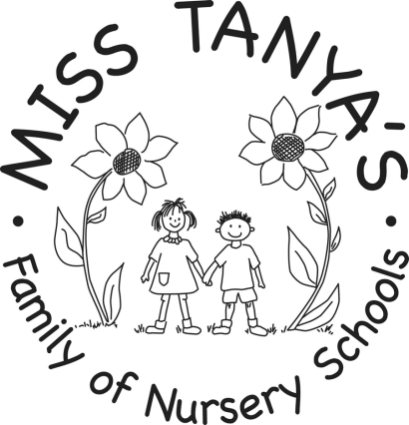

Miss Tanya’s Woodland School Inc.
7 Washington Street
Westborough, MA 01581
Phone: 508-366-5700
Fax : 508-366-5779
misstanya.com
woodland@gmail.com
Heather Straz Director

Dear Parents,

Our kindergarten program was created to offer families a natural next step for their child’s early childhood education. We are entering our twentieth year of offering kindergarten to a small number of families. The hours are Monday 8:30-11:30, and Tuesday through Friday 8:30-2:30. We offer a teacher/child ratio of 2:18. This small teacher child ratio lends itself beautifully to the needs of the kindergarten child.
Occasionally, we have some of our kindergartners taking part in what we call “the gift of a year” and they will move onto public kindergarten the following year. The remaining children will move onto first grade either in private or public school environments.
We are able to explore the diverse cultures of our kindergarten families through our country study from which our curriculum evolves. We strive to help your child learn to respect and honor differences among people.
Journal work, shared literacy, cross curricular activities and a print rich environment will help your child become a capable communicator. Children are introduced to a wide variety of literature, including big books, predictable books, fiction, nonfiction and poetry. Handwriting Without Tears is the handwriting program we integrate into our curriculum.
Our program also emphasizes social and emotional skills and growth. We encourage the children to deal with challenges and understand that to have a friend you must also be a friend.. Our social studies curriculum progresses from the self, to friends, family and finally to the community.
Children will have opportunities to engage in fine motor tasks, helping to develop hand-eye coordination and the pincer grip. Outdoor equipment such as our sand area, tire swing, climbing structures, slides and teeter totter offer gross motor development.
The curriculum includes trips to Teamworks, visits from the Discovery Museum, yoga classes, and visits from firefighters, dentists, and other community helpers.
Our primary goal is to offer children their first taste of what we hope will be a life-long love of learning!
Tours are offered for you and your child at any time. For more information and a tour of the school, please contact us!

Woodland Faculty

